Student Name: __katie caudill______ Date: ___________

Instructor Signature:_________________________________ Date: ___________

Point Assignment: ________________________
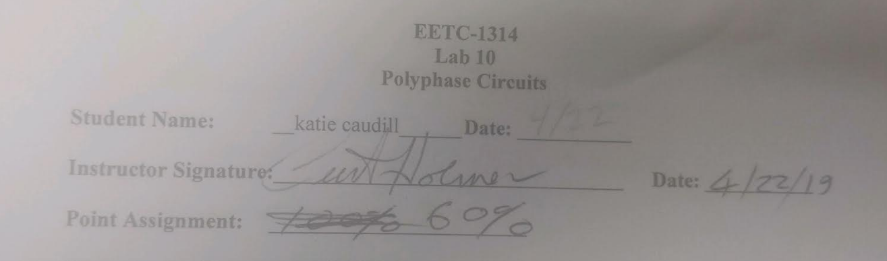

Purpose: The purpose of this laboratory experiment is to illustrate the fundamental voltage and current relationships of wye and delta connected polyphase circuits. The laboratory equipment is part of the LabVOLT electrical training system: (1) a three phase variable power supply, (2) three 300Ω resistive loads, (3) three 800mH inductive loads, (4) three AC voltmeters, (5) and three AC ammeters.

SAFETY CAUTION: This laboratory requires 120V and 208V in all experiments. You should treat this voltage level respectfully. Never handle a conductor terminal with Voltage exposed. Do not lean on the equipment. Do not remove a conductor unless power is removed from the LabVolt unit through the proper disconnect. Do not perform any type of wiring connection to the circuit unless power is removed from the LabVolt unit. Always verify that power is off by observation and measurement. Students must always have supervision from an experienced instructor or laboratory technician when working with the LabVOLT equipment.

Background: Although we are generally more familiar with electrical power in the form of a single voltage source (single phase), electrical power is generated and transmitted throughout the electrical power network as three voltage sources. The three voltage sources have the same magnitude with respect to ground and one another; however, the distinguishing feature of the three sources is the phase angle. Each source is 120º out of phase with the other two sources. We call this type of source configuration three phase power.

Most industrial plants utilize three phase power to drive large motor loads, machinery, and heating loads. In most applications, the sources are wired with a common point, called a wye connection, or star connection. The load, on the other hand, may be connected in a wye or delta configuration. In either configuration, the voltage across the load and the current flowing through the load are called phase voltages and phase currents. The voltage between the lines and the current flowing through the lines are called line voltages and line currents. In a wye configuration, the phase current is equal to the line current, whereas in a delta configuration the line voltage and phase voltage are equal.

In three phase systems, the technician must keep three basic relationships in mind to assist in understanding the voltage and current readings:
Y-Y Load side: Line Voltage, 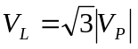 and Currents, 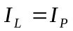

Y-∆ Load side: Line Current, 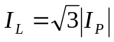 and Voltages, 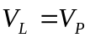

Y and ∆ loads: Power, 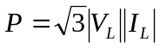

The angle relationship for the line voltage and line current assume a positive phase sequence for the source. [Phase sequence refers to the order in which the line voltages become positive. The phase sequence basically dictates the direction that motors rotate and whether two three phase systems can be interconnected.]If the source is supplied with a negative phase sequence, then the sign of the angles would be reversed.

Procedure:

- (10%) For the circuit shown below in figure #1, the voltage source and load are connected in a wye configuration. The line to neutral voltage is 120V_{rms}. Calculate the line-to-line voltages and the line currents, include the phase angle. [Note: 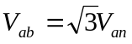 and 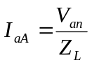, where Z_{L} = R.] . (Perform all calculations on a separate sheet and attach the calculations to the lab report.)
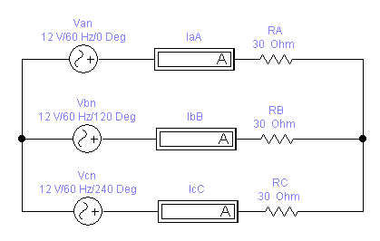
V_{an}
120V/60Hz/0 Deg
V_{bn}
120V/60Hz/-120 Deg
V_{cn}
120V/60Hz/120 Deg
I_{aA}
I_{bB}
I_{cC}
R_{A}
300Ω
R_{B}
300Ω
R_{C}
300Ω
Figure #1 – Circuit #1, Wye Load

Table #1 – Circuit #1 Calculation Results

Circuit #1 Calculation Results
Phase | Line to Line Voltage (V_{L}) | Line Current (I_{L}) | Power (V_{p}xI_{p})
A | V_{AB} = 208 < 30 V | I_{aA} = 400 <0 mA | 48 W
B | V_{BC} = 208 < -90 V | I_{bB} = 400<-120 mA | 48 W
C | V_{CA} = 208 < 150 V | I_{cC} = 400<120 mA | 48 W

- (10%) Using a LabVolt Electrical training system.
  - Verify that the power supply to the unit is OFF.
  - Turn the variac of the adjustable AC supply to 0 (CCW).
  - Turn power ON to the Labvolt Unit.
  - Adjust the variable AC supply phase voltage to 120VAC (4-N, 5-N, 6-N).
- Turn OFF the LabVolt power.
- Connect the circuit shown in figure #1 using the variable AC supply, AC ammeters, and a 300Ω resistor bank.
- The instructor or laboratory technician must verify the connections.
- Turn ON the power and measure the line voltage, the phase voltage, and the line current. Record the results in Table #2.
- Calculate the per phase power absorbed by each 300Ω load using the equation P=V_{p}xI_{p}.
- Once data has been recorded, set the power supply voltage to zero, turn off the power supply, and disconnect the circuit.

Table #2 – Circuit #1 Measurement Results

Circuit #1 Measurement Results
Phase | Phase  Voltage (V_{p}) | Line  Voltage (V_{L}) | Line  Current (I_{L}=I_{p}) | Power (W)  V_{p}xI_{p}
A | 120 V | 208 V | 400 mA | 48.3 W
B | 120 V | 208 V | 400 mA | 48.3 W
C | 120 V | 208 V | 400 mA | 48.3 W

- (10%) Using a low voltage three phase module, connect an oscilloscope to the output terminals to measure V_{an} and V_{bn} on channels #1 and #2, respectively. Remove V_{bn} from channel #2 and connect V_{cn} to this channel. Measure and record the phase difference between the two waveforms.

Table #3 – Wye Phase Angles

Phase Angle between V_{an} and V_{bn} | 121
Phase Angle between V_{an} and V_{cn} | 240
Phase Angle between V_{bn} and V_{cn} | 120

- (10%) For the circuit shown below in figure #2, the voltage source is connected in a wye configuration and the load is connected in a delta configuration. The source phase voltage is 69V (4, 5, & 6 to N) and the line voltage is 120V_{rms} (4-5, 5-6, & 6-4). Calculate the phase currents, the line currents, and the power absorbed by the load. [Note: 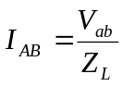, and 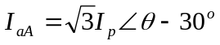(Z_{L} = R).]
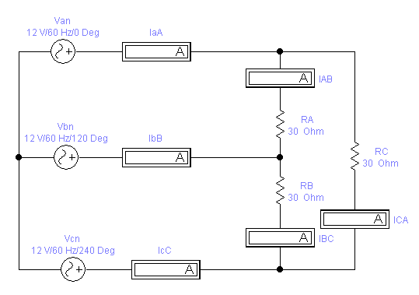
120VAC
120VAC
V_{an}
69V/60Hz/0 Deg
V_{bn}
69V/60Hz/-120 Deg
V_{cn}
69V/60Hz/120 Deg
I_{aA}
I_{bB}
I_{cC}
I_{AB}
I_{BC}
I_{CA}
R_{C}
300Ω
R_{A}
300Ω
R_{B}
300Ω
Figure #2 – Circuit #2, Delta Load

Table #4 –Delta Calculation Results
Circuit #2 Calculation Results
Phase | Line to Line  Voltage (V_{L}=V_{p}) | Phase  Current (I_{p}) | Line  Current (I_{L}) | Power (W)  V_{p}xI_{p}
A | 120 <30 | 398<30 mA | 689<0mA | 47.6W
B | 120<-90 | 398<-90 mA | 689<-120mA | 47.6W
C | 120<150 | 398<150mA | 689<120 | 47.6W

- (10%) Using a LabVolt Electrical training system.
  - Verify that the power supply to the unit is OFF.
  - Turn the variac of the adjustable AC supply to 0 (CCW).
  - Turn power ON to the Labvolt Unit.
  - Adjust the variable power supply line voltage to 120VAC (4-5, 5-6, 6-4).
- Turn OFF the LabVolt power.
- Connect the circuit shown in figure #2 using the variable AC supply, AC ammeters, and a 300Ω resistor bank. Since there are only 3 AC ammeters, connect the ammeters to measure the LINE CURRENT.
- The instructor or laboratory technician must verify the connections.
- Turn ON the power and measure the line voltage, the phase voltage, and the line current. Record the results in Table #5.
- Calculate the per phase power absorbed by each 300Ω load using the equation P=V_{p}xI_{p}.
- Turn OFF the power to the LabVolt Unit.
- Reconnect the AC ammeters to measure the PHASE CURRENTS as shown in figure #2.
- The instructor or Lab Technician must verify the connections.
- Turn ON the power and record the current measurements.
- Once data has been recorded, set the power supply voltage to zero, turn off the power supply, and disconnect the circuit.

Table #5 –Delta Measurement Results

Circuit #2 Measurement Results
Phase | Line to Line  Voltage (V) | Phase  Current (A) | Line  Current (A) | Power (W)
A | 120 V | 402 mA | 690 mA | 48.3 W
B | 120 V | 404 mA | 690 mA | 48.3 W
C | 120 V | 402 mA | 690 mA | 48.3 W

Three Phase Power
- (10%) Using the LabVolt equipment, connect a 300Ω resistor and 300Ω inductor in series with a 0-0.5A AC ammeter and a fixed voltage source (terminals #1, 2, & 3 on the power supply). See figure #3.
  - Turn on the power supply.
  - Measure the line current, the voltage across the inductor, the voltage across the resistor, and the total voltage across the inductor/resistor combo.

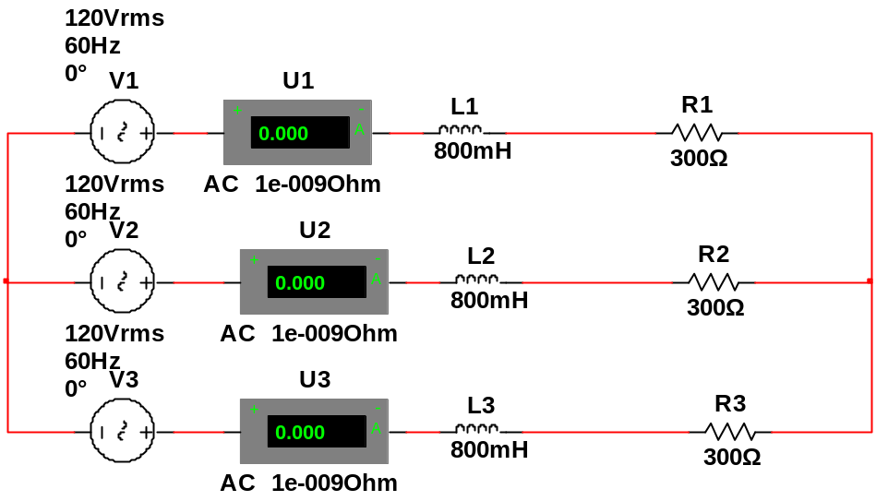

Figure #3: Circuit #3, Resistor & Inductor

Table #6 –WYE, Resistor & Inductor Circuit Measurement Results

Circuit #3 Measurement Results
Phase | Line  Current I_{L} | Resistor  Voltage  V_{R} | Inductor  Voltage  V_{I} | Total  Voltage | Average  Power V_{R}xI_{L} | Reactive  Power V_{I}xI_{L}
A | 280mA | 81.9 V | 81.5 V | 120 V | 22.7 W | 22.8 W
B | 280mA | 80.7 V | 80.9 V | 120 V | 22.6 W | 22.7 W
C | 280mA | 81.3 V | 80.9 V | 120 V | 22.8 W | 22.7 W

Questions (40%):
- Using the data recorded in table #2, compute the total power absorbed by the resistors by adding the power absorbed by phase A, B, & C.
144.9 w

- Using the data recorded in table #2, compute the total power absorbed by the resistors using the equation: 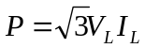. Note: use the average values for V_{L} and I_{L}. How does this power calculation compare to that in question #1?
144.1 w almost the same

- From the data recorded in table #2, ratio the average line voltage to the average phase voltage. Does this value equal approximately 1.73 or ?
208/120 = 1.73 = sqrt(3)

- From the data recorded in table #3, what is the phase relationship between the phase voltages V_{an}, V_{bn} and V_{cn}?
They are 120 degrees apart.

- Using the data recorded in table #5, compute the total power absorbed by the resistors by adding the power absorbed by phase A, B, & C.
144.9 w

- Using the data recorded in table #5, compute the total power absorbed by the resistors using the equation: . Note: use the average values for V_{L} and I_{L}. How does this power calculation compare to that in question #5?
143.1 w almost the same

- From the data recorded in table #5, ratio the average line current to the average phase current. Does this value equal approximately 1.73 or ?
1.725

- Using the data recorded in table #6, compute the total average power absorbed by the resistors by adding the average power of the resistors on phase A, B, & C (P_{T}). Also, compute the total reactive power absorbed by the inductors by adding the reactive power of the inductor on phase A, B, & C (Q_{T}). Use the total average power and total reactive power to find the total apparent power using: 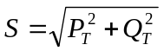
Pt= 68.4 W
Qt= 68.2 VAR
S= 96.59 VA

- Using the data recorded in table #6, compute the total power absorbed by the load using the equation: 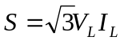. Note: use the average values for V_{L} and I_{L}. How does this power calculation compare to that in question #8?
S= 100.9 VA almost the same

- Does the voltage across the inductor and the voltage across the resistor add up to the total voltage across the load? Why or why not?
No. they are out of phase.

